#**RESULTS AND DISCUSSION**

In this project, we used different classification algorithm to train and test our model. Performance of all the classification algorithms are assessed by different statistical measurement aspects such as accuracy, specificity, f1-score etc. These classification measurement factors are calculated by the terms: True Positive (TP), False Positive (FP), True Negative (TN) and False Negative (FN). Here,

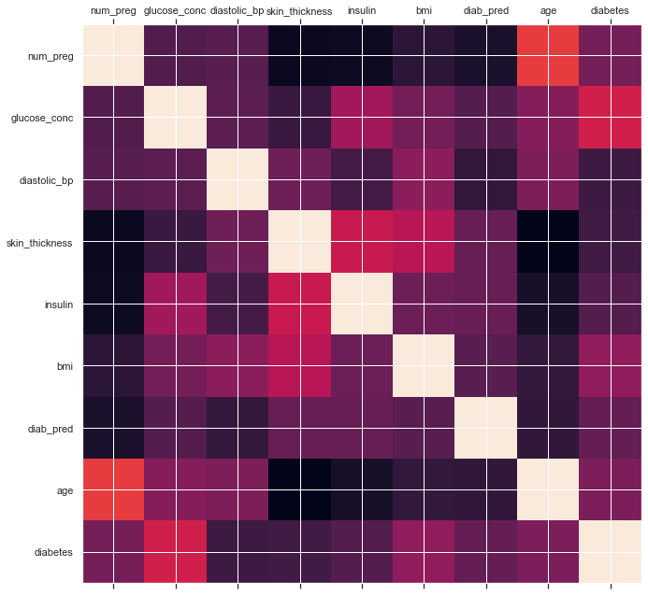From the Prima Indian Data set, 268 true samples and 500 negative samples were taken into analysis. We split the diabetes data set into two parts where the training set contains 70% and the test set contains the remaining 30% of the data, where, training true: 188 (35.01%), training false: 349 (64.99%), test true: 80 (34.63%) and test false: 151 (65.37%). Moreover, the dataset was also checked to verify the correlated features in order to drop the redundant columns.

In Figure 2:

Red is most correlated, Blue least.

Input:

data_frame: pandas DataFrame

size: vertical and horizontal size of the plot

Displays:

matrix of correlation between columns. Blue-cyan-yellow-red-dark red => less to more correlated

0 ------------------> 1

Expect a dark red line running from top left to bottom right

The K-fold cross validation approach is used to evaluate the performance of the prediction model. Predictions of all the machine learning classification algorithms ,Random Forest (RF) and Logistics Regression (LR) exhibits the highest performance and Decision Tree Model ( DT ) shows the lowest performance than the other 5 classification algorithms in terms of the four measurement factors: specificity, recall, precision and f1 measure in table 1:

Table 1. Classification performance measurements on the dataset

|  |  |  |  |  |  |  |
| --- | --- | --- | --- | --- | --- | --- |
| **Measurement**  **Techniques** | **N**B | RF | LR | ANN | SVM | DT |
| Accuracy | .76 | .78 | .78 | .74 | .77 | .70 |
| Precision | .74 | .76 | .77 | .71 | .75 | .67 |
| F-1 Score | .76 | .78 | .78 | .74 | .76 | .70 |
| Recall | .73 | .75 | .74 | .71 | .72 | .68 |

All the machine learning classifiers show the accuracy level of nearly 75%, which indicates that the performance of these techniques is pretty well. F-1 measure indicates (NB, SVM, DT, LR and RF) that the five-classification techniques mostly predict accurate results. From the above discussion, it is important to know about the Receiver Operating Characteristics (ROC) curve, which is based on the true positive rate (TPR) and false positive rate (FPR) of these classification results. The ROC curve is presented in Figure 5.

In summary, we highlight the research directions and scope in relation to Health Care Services (HCS) and Bio-medical fields by machine learning classification techniques. Hence, disease prediction by machine learning classification algorithms should be improved. We describe the most popular Artificial Intelligence techniques and give the purpose of our project which is a unified framework for diabetes prediction that require further research in terms of machine learning based disease prediction.